Windchill NA
CS Complaint Loader Issue
Document Purpose
This document is a production support knowledge transfer (KT) reference for the Windchill NA CS Complaint Loader debugging process.

1. Issue Summary
On June 3, 2026, the 7:30 AM ET CS Complaint file from Salesforce failed to load into Windchill. The file was received but the automated loader process crashed silently due to data corruption, leaving no email notification and no backup file.
Attribute | Details
File | complaints_CS_202606020730.txt
Missing Run | June 2, 2026, at 7:30 AM ET
Root Cause | Special characters in row 22, missing required fields (DC number, Medical Professional flag) in multiple rows
Total Records | 27 complaint records in the corrupted file
Action Taken | File located via SSH on source SFTP server; copied locally; analyzed in Excel; escalated to Salesforce

2. System Architecture Overview

2.1 CS Complaint File Processing Flow
The CS Complaint Loader Queue integrates Salesforce-generated complaint data into the Windchill PLM system on the FMCNA production environment. Understanding this flow is essential for diagnosing loading failures.
- Salesforce generates a CS complaint file.
- The file lands on the SFTP source server: rwl-pgwc-p01.dc.fmcna.com in /transfer/sd/sfdc/windchill/complaints/
- A scheduled script on Windchill master node (rwl-wc11bg-p01) picks up the file via SSH/SCP at :30 past and places it in the inbound folder
- The Windchill loader process runs on the hour (:00) and processes the file from: /ptc/Windchill_11.1/Windchill/integration/inbound/complaints_CS_<YYYYMMDD<HHMMSS>.txt
- On success: the file is moved to the backup folder, and an email notification is sent.
- On failure (data corruption): the process crashes silently - no email, no backup move, no log entry.
- Windchill get CS files at 7:30 AM and 12:30 PM and process them at 8:00 AM and 1:00 PM.

2.2 Key File Naming Convention
⚠ NOTE: The loader script looks for ONLY today's date. A file with any other date in the filename will NOT be picked up and will fail with "no file found."

File naming pattern: complaints_CS_<YYYYMMDD><HHMMSS>.txt
Example: complaints_CS_202606030730.txt
Only the YYYYMMDD portion (year+month+day) is matched. The time portion (HHMMSS) is ignored by the loader.

2.3 Relevant Servers & Paths
Server | Hostname | Key Path
Windchill Master Node | rwl-wc11bg-p01 | /ptc/Windchill_11.1/Windchill/integration/inbound/
Windchill Backup | rwl-wc11bg-p01 | /ptc/Windchill_11.1/Windchill/integration/inbound/backup/
Windchill Logs | rwl-wc11bg-p01 | /ptc/Windchill_11.1/Windchill/logs/
SFTP Source Server | rwl-pgwc-p01.dc.fmcna.com | /transfer/sd/sfdc/windchill/complaints/
CS Process Script | rwl-wc11bg-p01 | bin/process_Complaints_CS.sh

3. Investigation Walkthrough

3.1 Initial Check: Inbound & Backup Folders
- The investigation began by checking the Windchill inbound and backup folders on the production server.
- 12:30 PM file was present in backup; there was no corresponding 7:30 AM file.
- The last entry in backup was from April 28th before June 3rd's 12:30 PM run.

"ls -lrth complaints_cs_2026*" was used to filter the backup folder listing to 2026 files only, avoiding thousands of older entries.
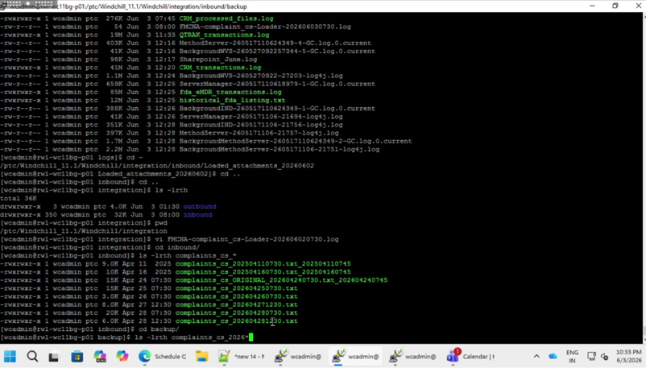
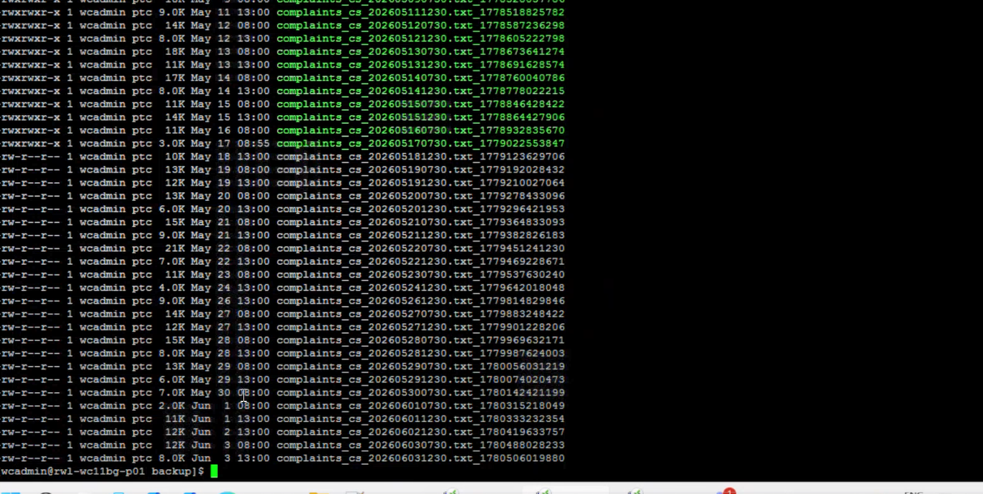
Figure 1: Backup folder on rwl-wc11bg-p01 showing complaints_CS_2026* listing. Note: June 2 7:30 AM file is absent; only the 12:30 PM file appears in backup.

3.2 Production Server - Integration Inbound
integration/inbound directory was checked. This confirmed the 7 AM entry was missing. Both the inbound folder listing and the logs were examined.
If there is a data corruption, there will be array out of bound exception and it stops execution.
If there is no error, it will process the file and at the end of the process email is generated and then moves the file from inbound to backup

3.3 Log File Review
The CRM_transactions.log file in the Windchill logs (/ptc/Windchill11.1/Windchill/logs) directory was opened to find the log entry for the missing CS file run. Using Shift+N to search, the following log entries were located:
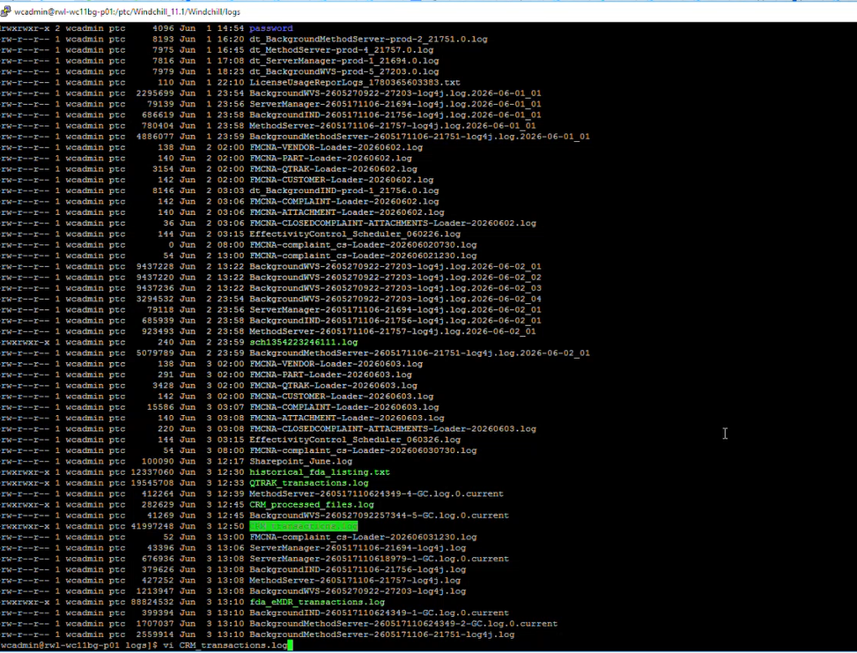
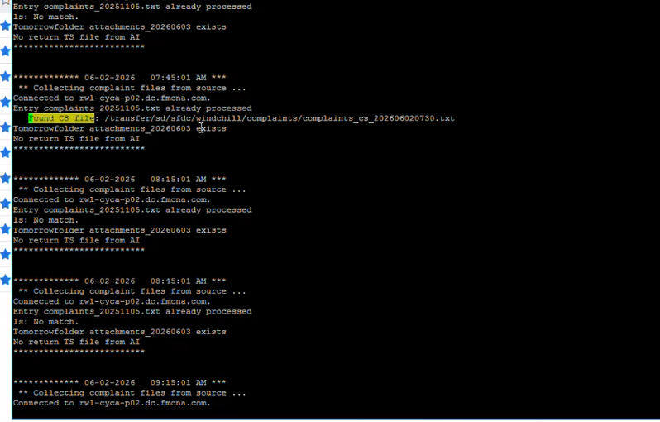
The file is moved to back up folder at the end of script. If the script is interrupted, the file will be moved away.

Here the file is not found (find command under windchill folder) –
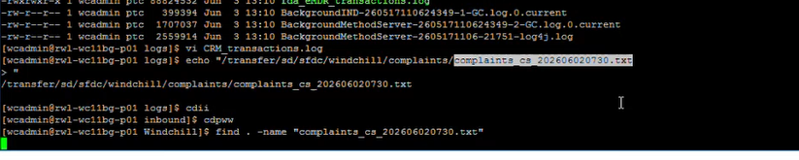

3.4 Locating and Copying the Missing File via SSH/SCP
With the file path from the logs, the source SFTP server was accessed via SSH. The file was located at the source and then copied back to the Windchill inbound folder.
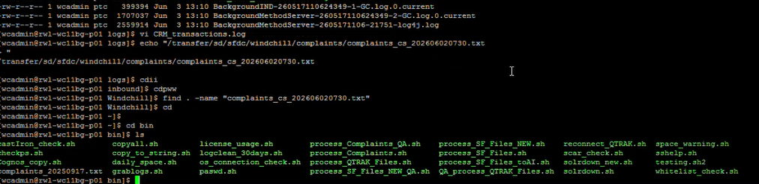
vi process_Complaints.sh
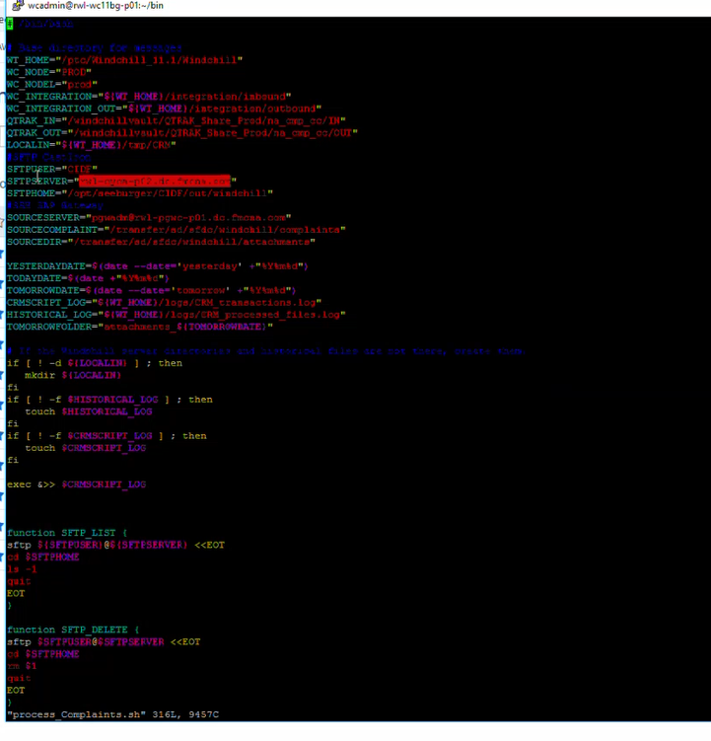

For complaints_CS

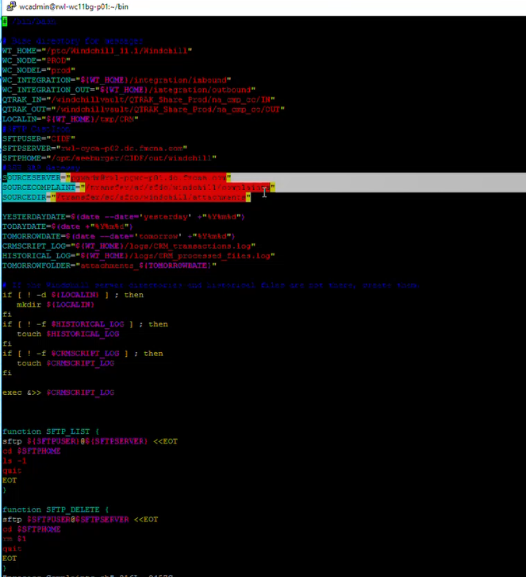
Commands used:
- ssh pgwadm@rwl-pgwc-p01.dc.fmcna.com
- 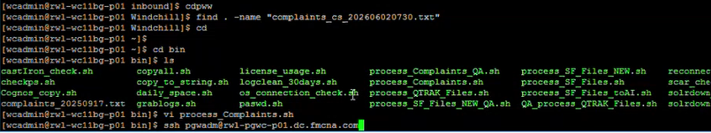
- cd /transfer/sd/sfdc/windchill/complaints/
- ls -lrth 2026 06* (to list June files only)
- 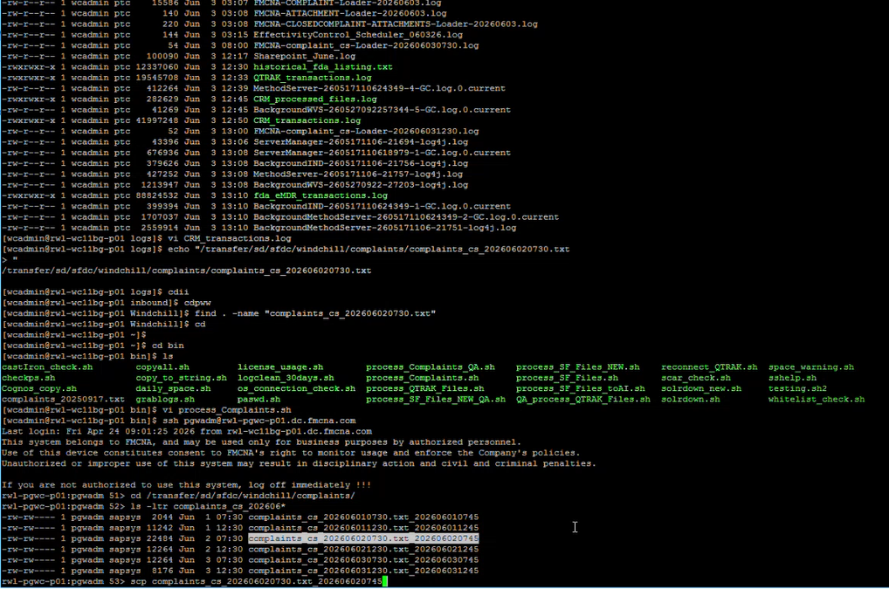
- 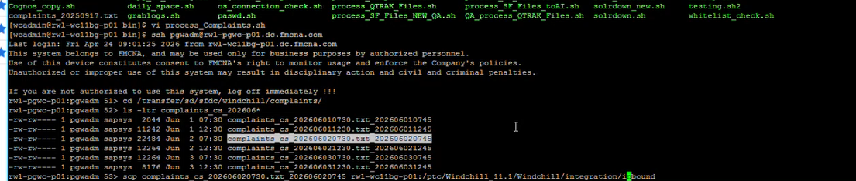

Exit and come back to bg node

Copy to bg node : scp -qp pgwadm@rw1-pgwc-p01.dc.fmcna.com:/transger/sd/sfdc/windchill/complaints/complaints_cs_202606020730.txt* .

3.5 Using WinSCP to Copy the File
- Open WinSCP
- Connect to bg node server: ptc/111/Windchill/integration/inbound
- Navigate to complaints_CS/202606
- Copy the file to local machine (22 KB, copies very quickly)

3.6 Opening the Complaint File in Excel
The file was copied locally and opened in Excel to analyze the corruption. Since the file is pipe-delimited, import settings were:
- File type: Delimited
- Delimiter: Pipe (|)
- Click Finish

3.7 Identifying Data Corruption
There was special character in line 22
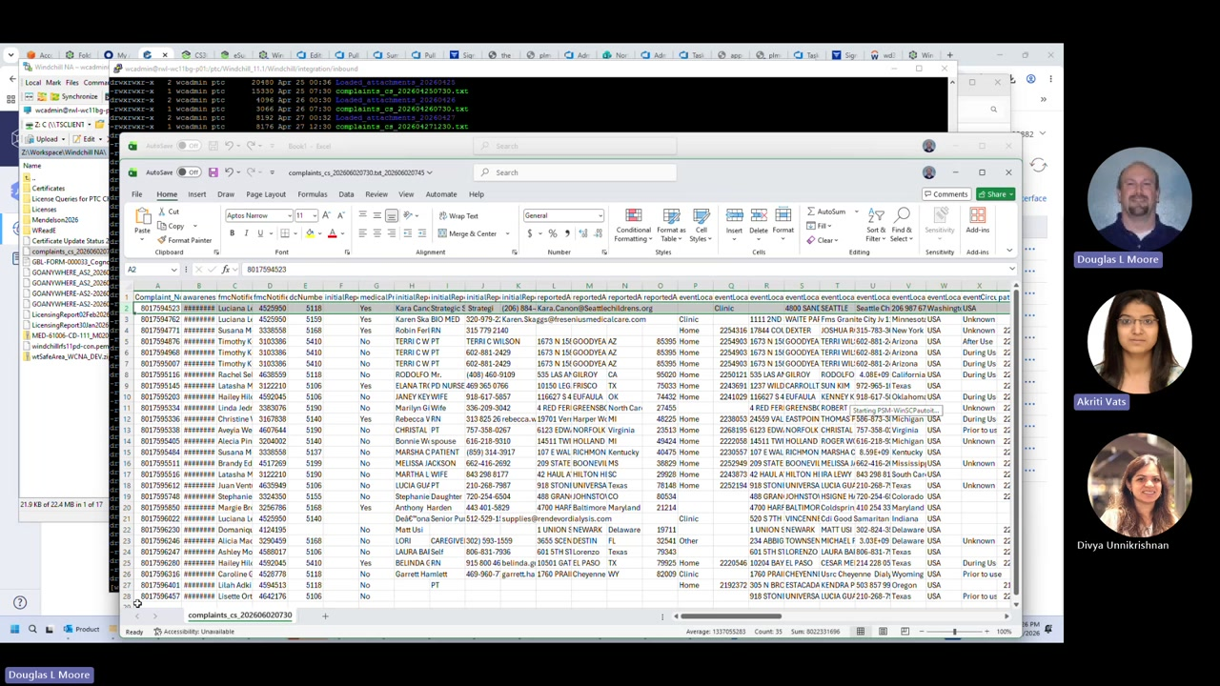
The complaint file opened in Excel showing 27 rows. Multiple corruption issues are visible including shifted columns, missing zip codes, and invalid field values.

Corruption Type 1: Extra Pipe / Shifted Columns (Row 2)
Row 2 contained an extra pipe-delimited field. This caused all subsequent column values to shift one position to the right. In the raw file, instead of: ...phone_number|next_field|... the Salesforce tool inserted: ...phone_number|extra_word|pipe|next_field|... This extra field caused the total column count to be greater than expected, resulting in the "array index out of bounds" error that crashed the entire loader for all 27 records.
.

Corruption Type 2: Special Characters
Row 22 contained special characters (non-UTF-8 alt characters) that are not in the allowed character set for Windchill load files. This appears to be a result of a previous field value bleeding into another field through some encoding issue.

Corruption Type 3: Missing Required Fields
Multiple rows had blank required fields including: DC number (distribution center - every US location should have one), Medical Professional flag (must be Yes/No, was blank), Event Location, City/State/Zip, and Reporter contact information. Without these, the complaints cannot be properly routed or investigated.

3.8 Email Escalation to Salesforce
The standard procedure is to always escalate to Salesforce first rather than attempting manual corrections. The email was sent by hijacking an existing email thread about similar prior issues (CS compliance file from April 7th) to maintain context and history.
Key recipients: Vineel (primary contact for Salesforce-to-Windchill data pipeline), ML Windchill IT, Windchill MS.
⚠ NOTE: Always use an existing related email thread when escalating recurring issues - it provides evidence history and prevents Salesforce from saying "I'll investigate" for the same problem repeatedly.

3.9 File Naming for Manual Reprocessing
When Salesforce provides a corrected file, the filename MUST be changed to today's date before placing it in the inbound folder. The loader script searches for today's date only.
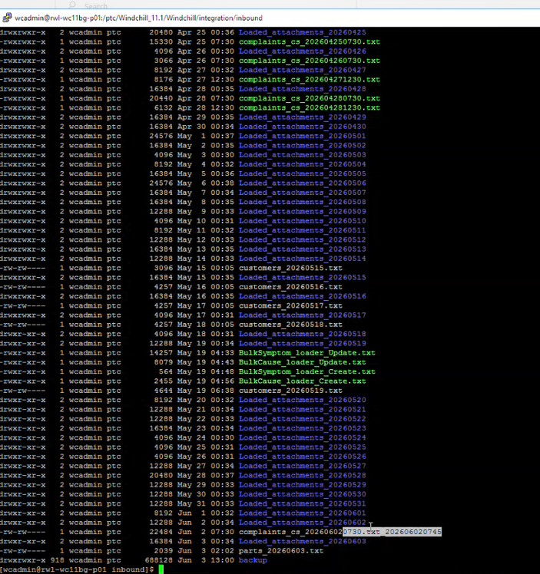
Figure 10: The filename must follow the pattern complaints_CS_<YYYYMMDD><any suffix>.txt where YYYYMMDD = today's date. Remove any extraneous timestamp suffixes.

3.10 Running the Integration Script Manually
After renaming and placing the file in the inbound folder, the integration script is run manually:
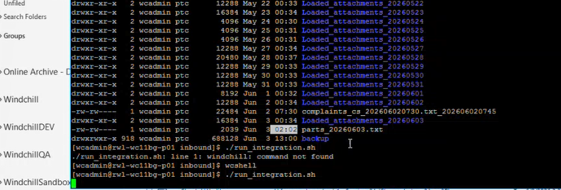
Figure 11: The run_integration script with option 5 (Customer Service) selected. For CS complaints, always choose the Customer Service option, not Tech Service.

4. Root Cause Analysis
The root cause of the CS Complaint Loader failure was bad data provided by Salesforce. The Salesforce-to-Windchill integration pipeline does not perform data validation before submitting files. Specifically:

- An extra pipe-delimited field was inserted into row 2 of the complaint file, possibly by the Salesforce tool experiencing a "hiccup" where it wrote a value, then a pipe, then another value, and then a pipe again - resulting in two fields where one was expected.
- The Windchill loader reads the entire file expecting a fixed number of fields per row. When one row has an extra field, the column count exceeds the expected count, and the Java loader throws an "ArrayIndexOutOfBoundsException" which causes the entire loader thread to terminate without processing any records.
- No error trapping exists in the current Java code to catch this exception and send a notification email - the process fails silently.
- The file is not moved to back up on failure, so the only indicators are: (1) no success email, (2) no backup file for that time slot, (3) no CVR records for affected complaints.

5. Resolution Steps (Step-by-Step)

Step 1: Detect the Issue
- Check the Outlook "Production System Notifications" folder - should see CS complaint emails at 8 AM and 1 PM on weekdays
- If either time slot is missing, check the backup folder: ls -lrth complaints_cs_2026*
- If no backup file for that time slot, the load failed

Step 2: Locate the Missing File in Logs
- SSH to rwl-wc11bg-p01 as wcadmin
- cd /ptc/Windchill_11.1/Windchill/logs/
- vi CRM_transactions.log
- Search with /CS file, press Shift+N to scroll through results
- Note the full path of the affected file from the log entry

Step 3: Locate the Source File
- The source file is on the SFTP server: rwl-pgwc-p01.dc.fmcna.com
- The path is: /transfer/sd/sfdc/windchill/complaints/
- Use: ssh pgwadm@rwl-pgwc-p01.dc.fmcna.com
- Then: ls -lrth 2026_06* to list June files
⚠ NOTE: You MUST use the pgwadm user, not wcadmin. The SSH key is configured for pgwadm. The files are owned by the SAP SYS group and wcadmin does not have read permissions.

Step 4: Copy the File Locally via WinSCP
- Open WinSCP (configured for Windchill emergency access)
- Connect to rwl-wc11bg-p01 > ptc > Windchill 11.1 > Windchill > integration > inbound
- Navigate to complaints_CS > 202606 (or relevant month)
- Copy the file to local workspace
- File is typically 10-25 KB and copies instantly

Step 5: Analyze the File in Excel
- Open Excel, Open File, locate the .txt file
- Choose Delimited, set delimiter to pipe (|)
- Examine each row for: extra/missing pipe characters, special characters, blank required fields
- Required fields to check: Medical Professional (Yes/No), DC Number, Event Location, Reporter info

Step 6: Escalate to Salesforce
- Do NOT manually fix the file unless it is a declared emergency
- Reply to the existing complaints CS email thread (maintain history)
- Recipients: Vineel (primary), ML Windchill IT, Windchill AMS
- Attach the original corrupt file (zipped)
- Clearly state what file, what date/time, what specific rows are corrupt, what fields are wrong
- Include a screenshot from Excel with the corruption highlighted

Step 7: Process the Corrected File (When Salesforce Returns It)
- Receive the corrected file from Salesforce.
- Open in Excel first and verify the corruption is fixed.
- Rename the file to today's date: complaints_CS_<YYYYMMDD>.txt (remove old timestamp)
- Place in: /ptc/Windchill_11.1/Windchill/integration/inbound/
- Run: run_integration > option 5 (Customer Service)
- Wait for the completion email notification.
- Verify the file moved to backup folder.
⚠ NOTE: After processing, DELETE the local copy of the file from your laptop immediately. Complaint files contain patient data and must not be retained on personal/local machines.

6. Key Procedures & Commands Reference
Task | Command / Procedure
List CS backup files (2026) | ls -lrth complaints_cs_2026* (run in backup folder)
View CRM log | vi CRM_transactions.log, then use /CS file and Shift+N
SSH to SFTP source server | ssh pgwadm@rwl-pgwc-p01.dc.fmcna.com
List June source files | ls -lrth 2026_06*
SCP file to inbound | scp pgwadm@rwl-pgwc-p01.dc.fmcna.com:/transfer/sd/sfdc/windchill/complaints/complaints_cs_202606020730*.txt .
Run integration (CS) | run_integration > select option 5 (Customer Service)
Rename for today's date | complaints_CS_<YYYYMMDD>.txt (remove time suffix, update date)
Open file in Excel | Delimited > Pipe delimiter > Finish
Find corrupted file | find / -name "complaints_cs_202606020730.txt" 2>/dev/null

7. Escalation Guidelines

7.1 When NOT to Manually Fix
Do not attempt to manually fix a corrupted Salesforce file The reason: if you fix it incorrectly, you own the mistake. Salesforce is the data supplier; let them correct their own data.

7.2 Email Template for Escalation
Subject: [Windchill CS Complaint Load FAILED] - <Date> <Time> - Data Corruption
Body should include:
- Specific file name (complaints_CS_<YYYYMMDD><HHMMSS>.txt)
- Date/time of missed load
- Screenshot showing the corrupt row(s) in Excel with column headers visible
- Specific issues called out: "Row 2 contains an extra pipe in the reporter phone number field causing ArrayIndexOutOfBounds. Row 22 contains special characters not in the allowed character set."
- Request: "Please correct and provide a new file for manual loading."
- Attach the original corrupt file (zipped)

8. Data Handling & Compliance
⚠ NOTE: CRITICAL: CS Complaint files contain patient data (HIPAA-sensitive). Strict data handling rules apply.

- Never retain complaint files on a local laptop beyond what is needed for the immediate investigation
- Once the issue is escalated and/or resolved, delete the local copy of all complaint files immediately
- Keeping files on the production Windchill server is acceptable (it is the intended system of record)
- The FMCNA team receives multiple annual trainings on patient data handling - these rules are enforced
- When sharing evidence with Salesforce, zip the file before attaching to email
- Do not forward complaint emails to personal email accounts

